**Command Line Instructions Document**

1. Set path for Java JDK if not already done to be able to compile the program.



1. Change working directory (using the cd command) to correct folder containing the project.



1. Enter “ javac CommandLineUI.java “ to compile the program.



1. Finally enter the command “ java CommandLineUI “. This will call the main method inside and construct a new instance of GUI.java. The program should run as normal now.

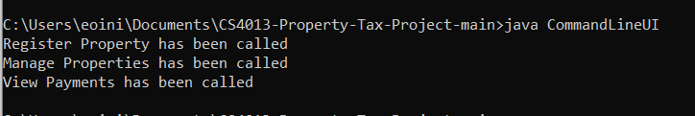

**GUI Instructions**

* 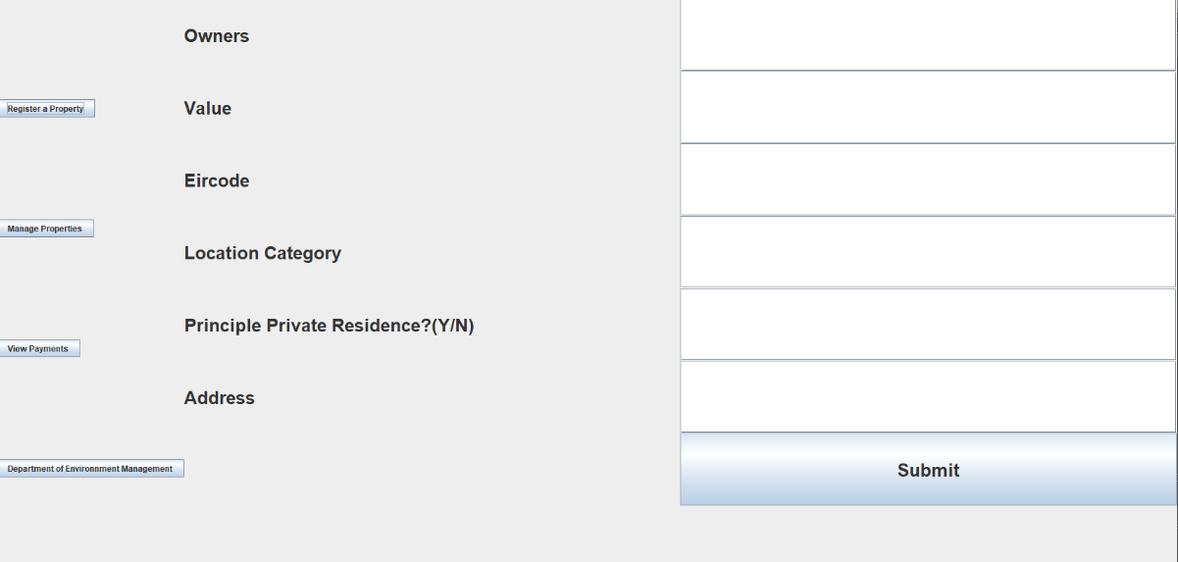Click on “**Register**” and fill in the fields on the right (no commas)
* Then click on “**Manage Properties**” and enter the address previously specified. This will now calculate the tax balance for that address and store it the JTable in “**View Payments**”.

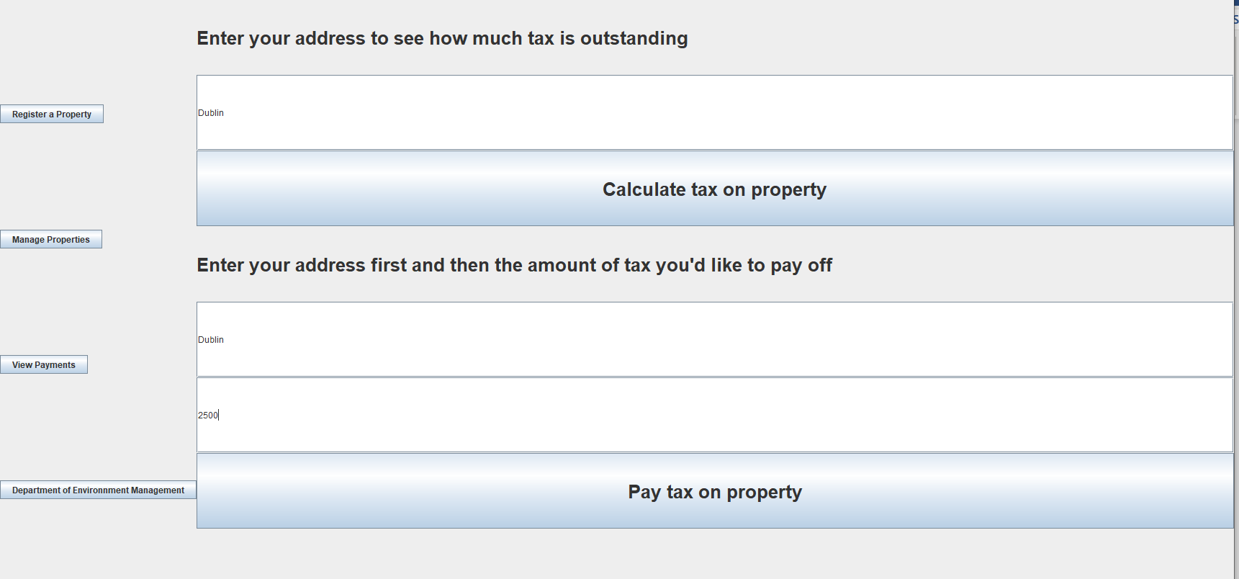

* Click on “**View Payments**” to view the registered property. To make a payment on the tax balance, go back into “**Manage Properties**” and enter the address and amount payable in the bottom two text boxes. Click submit and see the updated info in the “**View Payments**” section.

